Scratch Quick Start for Beginners
Very short orientation for Part 3: Building the Prototype
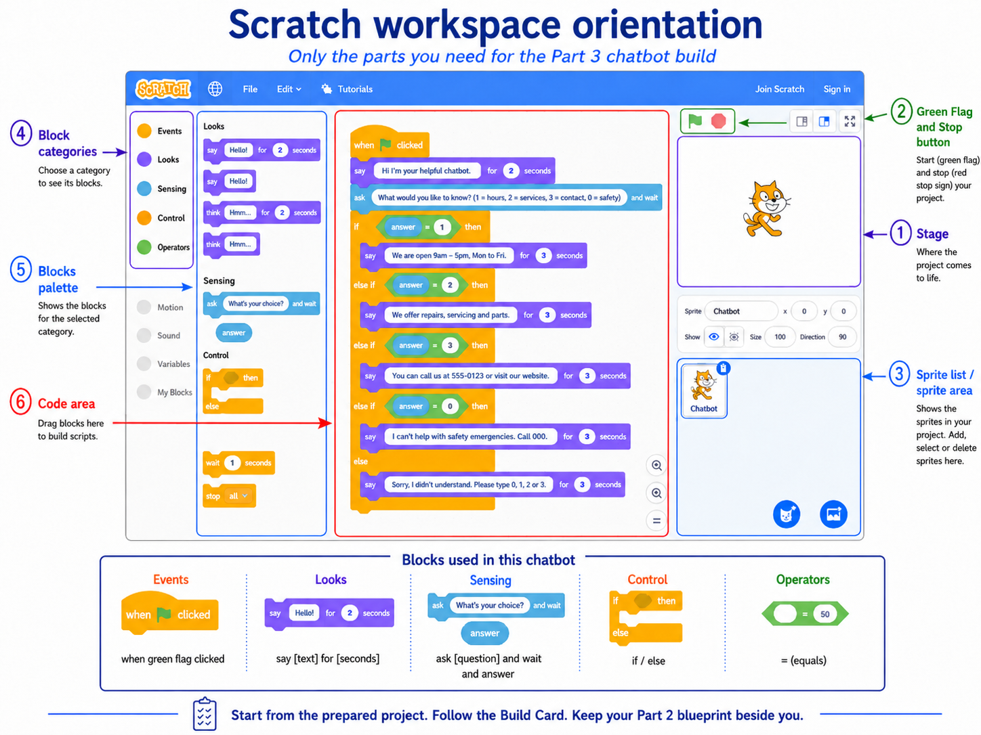
Scratch workspace orientation: the six areas and five block categories used in Part 3.
You do not need to learn all of Scratch for this task. For this chatbot, focus only on 6 parts of the screen and 5 block categories. Start from the prepared project, follow the Build Card, and keep your Part 2 blueprint beside you while building.

1. The six parts of Scratch you need
No. | Part of the screen | What you do there
1 | Stage | Watch what the chatbot says on the screen.
2 | Green Flag and Stop button | Start the project with the green flag and stop it with the red stop sign.
3 | Sprite list / sprite area | Select the chatbot sprite. This is the character you are programming.
4 | Block categories | Choose the block family you need, such as Events or Looks.
5 | Blocks palette | Find the exact block and drag it out.
6 | Code area | Connect the blocks here to build the chatbot logic.

2. The five block categories you need for this chatbot
Category | Main block(s) you will use | Why you need it
Events | when green flag clicked | Starts the chatbot.
Looks | say [text] for [seconds] | Makes the chatbot speak.
Sensing | ask [question] and wait, answer | Gets the user's choice.
Control | if / else | Chooses which branch should run.
Operators | = (green diamond block) | Checks whether the answer is 1, 2, 3 or 0.

Remember: you do not need every Scratch category. Ignore the rest unless your teacher tells you otherwise.

3. What to do first in Part 3
- Open the prepared Scratch project.
- Keep your Part 2 blueprint beside you. Do not redesign the chatbot.
- Follow the Scratch Build Card step by step.
- Build the minimum routes first: 1, 2, 3, 0, and “other”.
- Only after the routes work, complete the Build Record and save the project.
4. What the minimum chatbot must do
• Say a short introduction so the user knows what the chatbot does.
• Offer 3 main choices linked to the approved categories from Part 2.
• Show the correct response for choice 1, choice 2, and choice 3.
• Show a limitation / safety response for choice 0.
• Show a fallback response for any other input.
• Make the Part 1 design requirement visible in the prototype.
5. Quick help if something goes wrong
Problem | What to check
A block will not connect. | Drag it more slowly and look for the white connection highlight.
The wrong response runs. | Check the blue answer oval, the green = block, and the number in that branch.
The chatbot does not start again properly. | Click Stop, then click the green flag again.
Final reminder: build the logic first. Decoration comes later, only after the minimum routes run correctly.
Next: follow the Scratch Build Card step by step.

